Microkernel (Plug-in) Pattern
# Source: AI Source: Provided by: [Data Path: Persons Table -> ID Column: 1, Name_En Column: Motasem Essam] -> From: [ChatGPT] on [1/23/2026]
The Microkernel Pattern (also called Plug-in Architecture) is used for applications that require a core system with extensible features via plug-ins.
👉 Think of it as a minimal core system that can be enhanced by independently developed modules (plug-ins).

🔑 Key Idea
# Source: AI Source: Provided by: [Data Path: Persons Table -> ID Column: 1, Name_En Column: Motasem Essam] -> From: [ChatGPT] on [1/23/2026]
- Core system provides essential services
- Plug-ins extend functionality without changing the core
- Enables flexibility, maintainability, and modularity

🧱 Structure
# Source: AI Source: Provided by: [Data Path: Persons Table -> ID Column: 1, Name_En Column: Motasem Essam] -> From: [ChatGPT] on [1/23/2026]
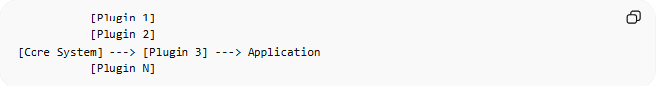
[Plugin 1]
[Plugin 2]
[Core System] ---> [Plugin 3] ---> Application
[Plugin N]
- Core System → Provides minimal, essential services (kernel)
- Plug-ins → Independent modules that add specific features
- Application → Uses core + plug-ins

🧩 Example – IDE (Integrated Development Environment)
# Source: AI Source: Provided by: [Data Path: Persons Table -> ID Column: 1, Name_En Column: Motasem Essam] -> From: [ChatGPT] on [1/23/2026]
- Core System → Text editor, project management, basic compiler
- Plug-ins → Syntax highlighting, code linting, version control, debugger
- Application → Fully featured IDE like Eclipse or Visual Studio
User installs Eclipse → Core editor runs → Add Python plugin → Python development enabled

❌ Bad Example (No Plug-in System)
# Source: AI Source: Provided by: [Data Path: Persons Table -> ID Column: 1, Name_En Column: Motasem Essam] -> From: [ChatGPT] on [1/23/2026]
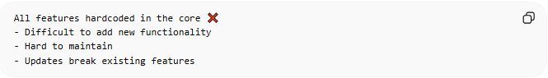
All features hardcoded in the core ❌
- Difficult to add new functionality
- Hard to maintain
- Updates break existing features

✅ Good Example (With Microkernel + Plug-ins)
# Source: AI Source: Provided by: [Data Path: Persons Table -> ID Column: 1, Name_En Column: Motasem Essam] -> From: [ChatGPT] on [1/23/2026]
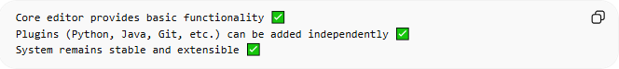
Core editor provides basic functionality ✅
Plugins (Python, Java, Git, etc.) can be added independently ✅
System remains stable and extensible ✅

🔄 Use Cases
# Source: AI Source: Provided by: [Data Path: Persons Table -> ID Column: 1, Name_En Column: Motasem Essam] -> From: [ChatGPT] on [1/23/2026]
- IDEs (Eclipse, Visual Studio)
- Web browsers (Chrome, Firefox) with extensions
- Enterprise apps with modular features
- OS kernels with device drivers

⚠️ Common Mistakes
# Source: AI Source: Provided by: [Data Path: Persons Table -> ID Column: 1, Name_En Column: Motasem Essam] -> From: [ChatGPT] on [1/23/2026]
- Core system too large ❌ (loses flexibility)
- Plug-ins tightly coupled to core ❌
- Poor plug-in management (version conflicts, instability) ❌

💡 Key Idea
# Source: AI Source: Provided by: [Data Path: Persons Table -> ID Column: 1, Name_En Column: Motasem Essam] -> From: [ChatGPT] on [1/23/2026]
The Microkernel Pattern separates the core functionality from optional features, making the system modular, extensible, and easier to maintain.

🧾 Summary
# Source: AI Source: Provided by: [Data Path: Persons Table -> ID Column: 1, Name_En Column: Motasem Essam] -> From: [ChatGPT] on [1/23/2026]
- Core → Minimal essential functionality
- Plug-ins → Independent modules extending the core
- Benefits: flexible, modular, maintainable, and scalable

